Autodesk Inventor: Importing Bmad Lattice

D. Burke, J. Conway, C. Mayes

CLASSE

**Scope**

The purpose of this document is to define a technique for accurately importing data from Bmad software into Inventor. The document will go through some of the terminology used in both programs, the importance of linking the software and instilling a best practice on the use of coordinate systems in Inventor.

Automatically linking Emad to Inventor through an API is out of scope for this document. Exporting files out of Emad is also out of scope.

**Introduction**

Importing a Bmad lattice file into Autodesk Inventor plays a crucial role in tying the analysis from the physics group into the mechanical realization of magnet locations. The CBeta FFAG-ERL project is being deployed in Wilson Lab’s L0E Hall at Cornell. There will be hundreds of magnets being placed to form the loop where beam trajectory relies on the accuracy of the placement of each element.

The outputted BMAD lattice file consists of over 900 rows of data each having six degrees of freedom defined. Each row defines one coordinate system; X, Y, Z distances from the origin and angles from the X,Y,Z axis. In Inventor terms, this is called a user coordinate system or UCS.

The method of using UCSs in Inventor or any CAD program is an efficient and accurate technique of placing components and defining features. In the ERL lattice models in Inventor; the coordinates imported from Bmad will drive magnet location and help define the vacuum chamber design, beam position monitor locations, surveying points and an abundance of other useful information.

Table of Contents

Definitions 2

Abbreviations 2

1. Bmad ERL Lattice 4

2. Coordinate Systems in Inventor 4

2.1. World Coordinate System 4

3. ERL Lattice File in Inventor 5

4. Parameter Function 7

5. iLogic 7

References 8

# Definitions

|  |  |
| --- | --- |
| Origin | The fixed absolute position to where data is derived. In CAD, this is the mathematical zero point and is often characterized by three mutually perpendicular planes. |
| Lattice |  |
| CAD Coordinate System | A defined point in space characterized by points, planes and axis. |
| Degrees of Freedom | The six movements that feature and components are defined to move. The six movements are X, Y and Z translation and the rotation about the X, Y and Z axis. Below is a list of features with the corresponding number of allowable directional movements.  CSYS = 0 DoF, all 6 movements are constrained  Axis = 2 DoF, translation & rotation along & about the axis  Plane = 3 DoF, translation in two direction and rotation about the normal axis  Point = 3 DoF, all three rotation but no translation |
| Element | The individual components in a Bmad lattice. These include but are not limited to magnets, pipes and solenoids. |
| Inventor | The primary CAD system used at Cornell for mechanical design and layout. Inventor is a product of Autodesk which also offers AutoCAD suite of products. |
| ProENGINEER | The primary CAD system used at BNL. Also referred to as ProE. |

# Abbreviations

|  |  |
| --- | --- |
| Abbreviation | Description |
| UCS | User Coordinate System |
| CSYS | Coordinate System |
| DoF | Degree of Freedom |
| BNL | Brookhaven National Laboratory |
| Bmad |  |
| MZP | Machine Zero Point |

# Bmad ERL Lattice

The various routines available in Bmad are extremely important in the development of the ERL project. For information on Bmad, see the reference section.

For purposes of this document, the Bmad ERL lattice simply consists of magnets which define the beam trajectories in the ERL. The Bmad ERL lattice also includes cavities, pipes, solenoids, instruments, etc. but can also include other elements such as girders and BPMs which can define the position of other elements.

As the mechanical design matures, parameters can be made available for inputting into Bmad for analysis. For example, the mechanical tolerances of magnet, BPM and girder locations can be made available for routines which can predict whether the system can correct for these offsets. The results can help derive final requirements.

The element locations in Bmad are always defined by its geometrical center. This is convenient for locating CAD models in Inventor (or any other CAD model).

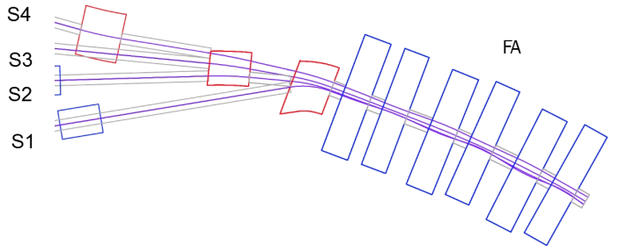 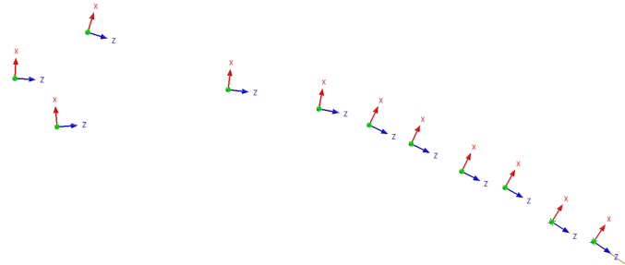

*Figure 1: Left image, a portion of the Bmad ERL Loop. Corresponding Inventor UCSs on the right.*

# Coordinate Systems in Inventor

Coordinate systems (CSYS) in a CAD program are convenient for quickly and accurately locating components. However, forethought and planning needs to be considered when setting up the CAD models. Part models must have CSYS which matches the intended position defined by the CSYSs in the assembly. In other words, location and orientation are predefined.

CSYS are also convenient because all 6 DoF are constraints. Using one CSYS as the component’s assembly constraint fully defines the placement of the component if used properly.

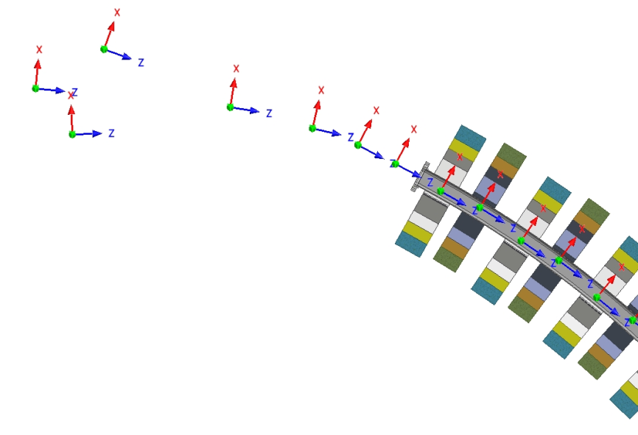

*Figure 2: QF and QD magnets constrained to UCSs*

# Absolute Coordinate System

Absolute, World, MZP, Origin are various terms to describe the mathematical “zero” position in a system or layout.

The zero points are represented by one or more datum features. The feature is usually a coordinate system but can also be planes, axis and center points. In Inventor, the Origin is not a coordinate system (nor a feature) but a group of planes, axis and a center point at the zero position. A UCS can easily be placed at the zero point with offsets set to 0 (zero).

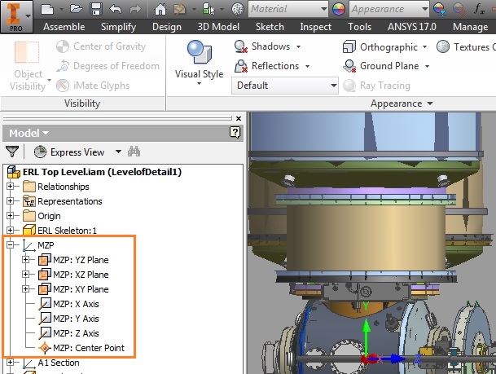

*Figure 3: planes, axis and a center point embedded in an Inventor’s UCS*

To be written…

# Coordinate System for Surveying

To be written…

# Coordinate Systems for CBeta Design Teams

To be written…

# Reference vs Absolute Coordinate Systems

To be written…

Examples…

# Inventor, Importing the ERL Lattice File

The Bmad files that are provided from the Physics group are in an ASCII format. These files have to be converted into CSV files which can then be converted to Excel. The file cbeta_4pass_20160517.layout_table was used to create the Excel file which drives lattice models.

The Excel file is imported into Inventor and “linked” to drive model parameters. However, setting ground rules for this file is as important as the file itself.

Highlights:

1. One file can drive many parts.
2. The second sheet of the file is a copy and paste from the original Bmad file. Formatting of this file needs to be consistent for updating purposes.
3. The first sheet uses the Excel function “VLOOKUP” to use values from the second sheet.
4. The UCSs are as accurate as Bmad.

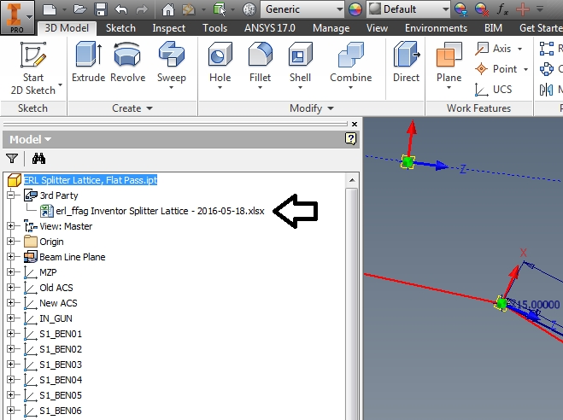 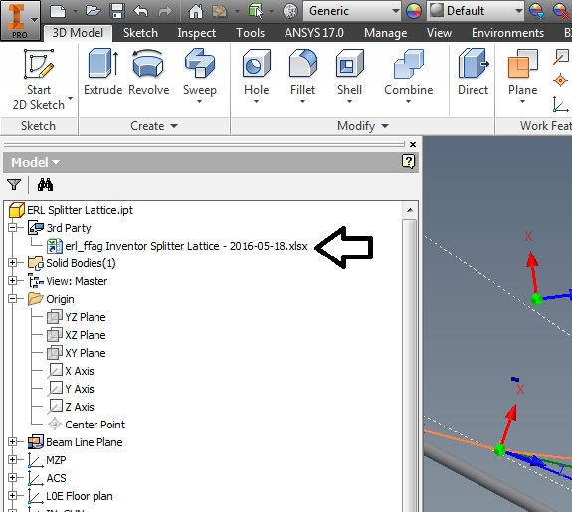

*Figure 1: Two models driven from one Excel*

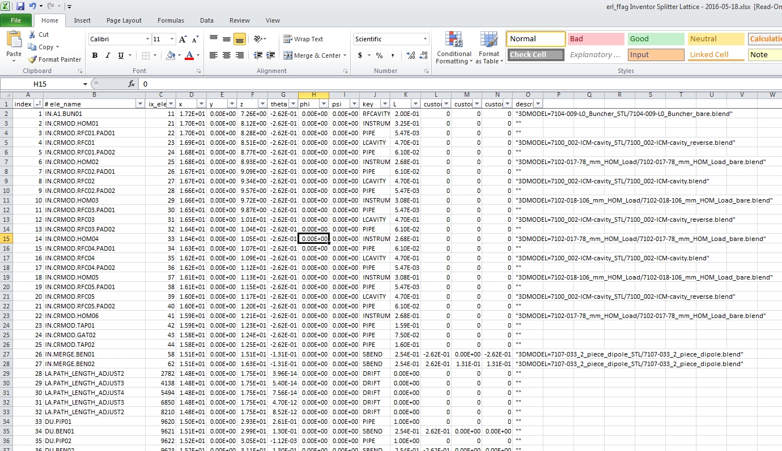

*Figure 2: Excel’s second sheet*

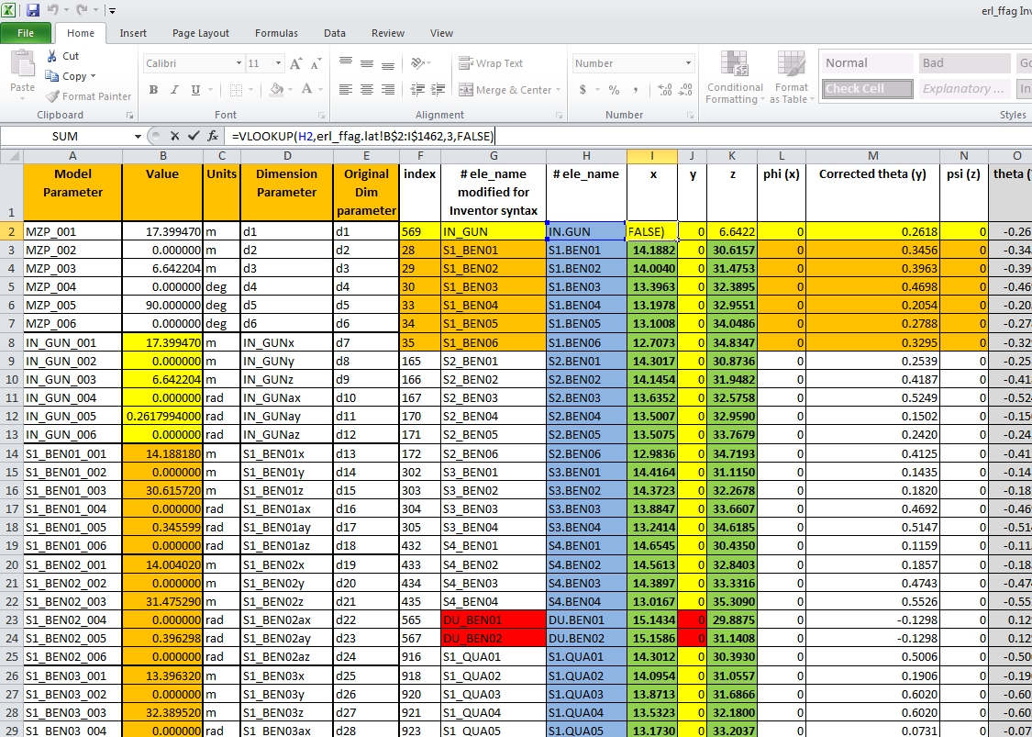

*Figure 3: Excel’s first sheet and VLOOKUP function*

# Naming Convention and Revision control

To be completed…

It is suggested to add a date stamp directly into Bmad that can be imported into the Excel spreadsheet. This has been found to be the best way to tie the Bmad revision to the CAD models.

# Parameter Function

Linking the file in Parameters

Once a lattice file is imported into Inventor they become the CAD model parameters.

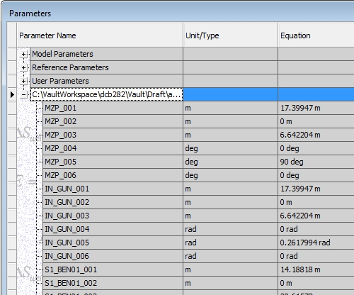

Figure 4: Linking in Inventor

# iLogic

Using the iLogic feature in Inventor is the quickest technique to create UCSs and tie them together with the Bmad lattice parameters. Otherwise, there will be hours of manual typing which is prone to typos and other errors.

# Steps to creating UCSs and linking the Bmad lattice

These are the steps in Inventor to create UCSs and drive the dimensions using the lattice parameters. A typical lattice file will have 100s of points which may change throughout the development of the accelerator.

# Create a spreadsheet in Excel

The first three columns in the first sheet in Excel will drive the model. The second sheet will have the imported lattice table separated by rows and columns. The third, optional, sheet will help tie the parameters with the UCS driven dimensions in the correct syntax needed in iLogic Rule1.

# Linking the Spreadsheet

Use the parameter function to import the spreadsheet. The spreadsheet should be added to the root folder of the CAD model.

**fx >> Link >> ‘select file’**

Choose ‘Immediate Update’ and ‘Link’ options. The selected file will be added to the iLogic Rule0

# Rule0

In iLogic, type (or copy and paste) the following text. Be sure to change the name of the file in the text that corresponds to file selected in step 4.1.2 which is seen below in **bold blue text**. The name “Rule0” was chosen as the default name given.

**Add rule >> Rule0 >> type the following text:**

' Create a new part document

Dim oDoc As PartDocument

oDoc = ThisApplication.ActiveDocument

' Set a reference to the PartComponentDefinition object

Dim oCompDef As PartComponentDefinition

oCompDef = oDoc.ComponentDefinition

Dim oTG As TransientGeometry

oTG = ThisApplication.TransientGeometry

GoExcel.Open("3rd Party:**name of file here**", "Linked")

' Create an empty definition object

Dim oUCSDef As UserCoordinateSystemDefinition

oUCSDef = oCompDef.UserCoordinateSystems.CreateDefinition

LastRow = 10000

k=2

While k < LastRow

UCSName = GoExcel.CellValue("A"&k)

' Create the UCS

Dim oUCS As UserCoordinateSystem

oUCS = oCompDef.UserCoordinateSystems.Add(oUCSDef)

oUCS.Name = UCSName

k = k + 6

End While

# Rule1

Rule1 is tying the lattice parameter to UCS dimensions. Six dimensions drive one UCS. 3 translation and 3 rotation. With the help of the third sheet in Excell, type (or copy and paste) these lines into Rule1. The dimension IDs that drives the UCSs need to be identified properly. This can be a source of errors.

Below is an example of six lines that will drive one UCS.

Parameter("d1") = "IPx"

Parameter("d2") = "IPy"

Parameter("d3") = "IPz"

Parameter("d4") = "IPax"

Parameter("d5") = "IPay"

Parameter("d6") = "IPaz"

References:

1. Bmad Software Toolkit for Charged-Particle and X-Ray Simulations. <http://www.lepp.cornell.edu/~dcs/bmad/overview.html>